Data Analytics - Assignment 3

Supermarket Sales Dashboard

Name : Sai Dhanya Kollu

# Roll Number:22BFA32068

Course : Data Analytics with Tableau

Objective:

The objective of this assignment is to analyze super-mal-ket sales data collected from three different branches over a three-month period. -Ille analysis focuses on understanding sales distribution, trends over time, and payment patterns to assist in better decision-making in a competitive market.

Process Followed:

Imported the provided supermmet sales dataset into Tableau.

1. Removed unnecessary columns that were not useful for the analysis.
2. Created four individual chans :

 Sales per Branch: Comparison of total sales among branches A, B, and C. o Sales by Product Line: Sales distribution across di fferent product categorieso Sales Trend Over Time: Monthly sales trends over the three-month period.  Payment Distribution; Sales split by payment methods like Cash, Credit Card, and E-wallet.

1. Combined all charts into a single interactive dæshboard using containers for proper layout.

Dashboard :

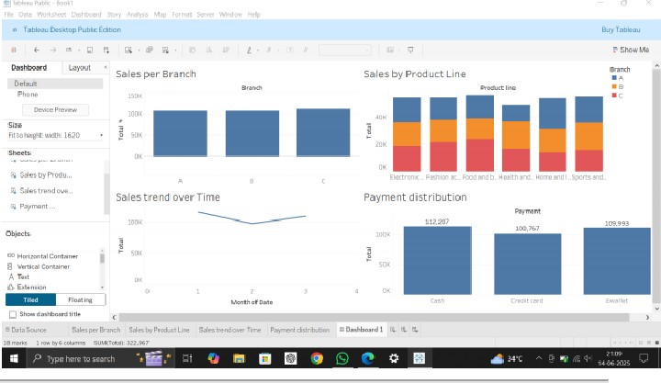

The dashboard provides a clear overview of:

* + Which branch performs be:st.
  + Which product lines generate higher sales The trend of sales over the selected period.
  + Preferred customer payment methods